Experiment No.: 4
1.Title: To develop a JavaScript-based web application that checks whether a given string is a palindrome, while demonstrating the use of function declarations, function expressions, arrow functions, closures, and exception handling (try-catch) in JavaScript.
2. Software/Tools Required: VSC, HTML, CSS
3. Theory:
A palindrome is a word that reads the same backward as forward, like "madam" or "racecar".
In this program, we check this in a simple way:
- A function is written that reverses the string and checks if the reversed string is the same as the original. If they match, the word is a palindrome.
- Before checking, the input is cleaned up — all letters are converted to lowercase and spaces/symbols are removed. This way, even phrases like "Madam" are checked correctly.
- A counter is also used to keep track of how many times the user has checked a word. This counter remembers its value between clicks — this is called a closure.
- If the user clicks "Check" without typing anything, the program doesn't crash. Instead, try-catch is used to show a proper error message.
- Finally, JavaScript is connected to the HTML page to take input from the user and show the result on the screen.
- Code:
<!DOCTYPE html>
<html lang="en">
<head>
<meta charset="UTF-8">
<title>Palindrome Checker</title>
<style>
body {
font-family: Arial, sans-serif;
background: #1e1e2f;
color: #eee;
display: flex;
justify-content: center;
padding-top: 60px;
}
.box {
background: #2a2a3d;
padding: 30px;
border-radius: 10px;
width: 350px;
}
h2 { margin-top: 0; text-align: center; }
input {
width: 100%;
padding: 10px;
font-size: 15px;
border-radius: 5px;
border: none;
margin-bottom: 12px;
box-sizing: border-box;
}
button {
width: 100%;
padding: 10px;
background: #4CAF50;
color: white;
border: none;
border-radius: 5px;
font-size: 15px;
cursor: pointer;
}
button:hover { background: #45a049; }
#result {
margin-top: 15px;
text-align: center;
font-weight: bold;
min-height: 20px;
}
</style>
</head>
<body>

<div class="box">
<h2>Palindrome Checker</h2>
<input type="text" id="wordInput" placeholder="Enter a word">
<button onclick="handleCheck()">Check</button>
<p id="result"></p>
</div>

<script>

// 1. FUNCTION DECLARATION
// Basic logic: checks if a string reads the same forward and backward
function isPalindrome(str) {
let reversed = str.split("").reverse().join(""); // local scope variable
return str === reversed;
}

// 2. FUNCTION EXPRESSION
// Cleans the input: lowercase + removes spaces/punctuation
const cleanInput = function (str) {
return str.toLowerCase().replace(/[^a-z0-9]/g, "");
};

// 3. ARROW FUNCTION
// Simple counter using a closure to remember how many times we checked
let countChecks = (function () {
let count = 0; // private variable, remembered via closure
return () => ++count;
})();

// 4. FUNCTION using TRY-CATCH
// Handles bad input safely without crashing the page
function handleCheck() {
const resultEl = document.getElementById("result");

try {
const input = document.getElementById("wordInput").value;

if (!input || input.trim() === "") {
throw new Error("Please enter something to check.");
}

const cleaned = cleanInput(input);
const result = isPalindrome(cleaned);
const attempt = countChecks();

resultEl.style.color = result ? "#4CAF50" : "#e57373";
resultEl.textContent = result
? `✓ "${input}" is a palindrome (check #${attempt})`
: `✗ "${input}" is not a palindrome (check #${attempt})`;

} catch (err) {
resultEl.style.color = "#e57373";
resultEl.textContent = "⚠ " + err.message;
}
}

</script>
</body>
</html>

4. Output:
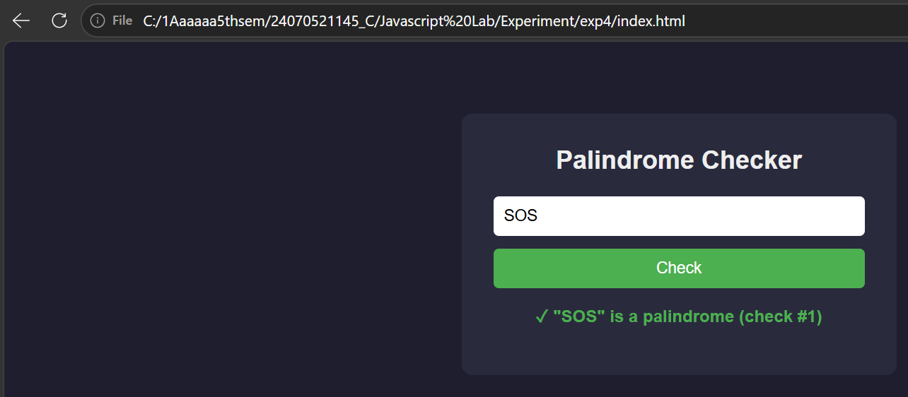
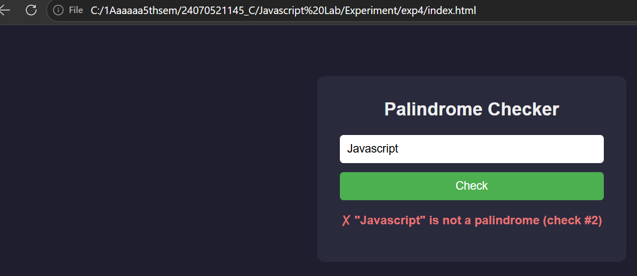
5. Result/Conclusion: Thus, a JavaScript program to check whether a given string is a palindrome was successfully designed and implemented. The program demonstrates the practical application of function declarations, function expressions, arrow functions, closures, and try-catch exception handling, along with basic DOM manipulation for building interactive web applications.

